Material Balance
- What is material balance?
  - Accounts for the mass flowing into, within, and out of a defined system. Based on the Law of Conservation of Mass: mass can neither be created nor destroyed.
- Basic formula for these types of problems:
  - Input + Generation -Output -Consumption = Accumulation
    - Input = what comes in across a system boundary
    - Generation = (for balances that include a chemical reaction) What is produced within the system
    - Output = what leaves across the system boundary
    - Consumption = what is consumed within the system (from chemical reaction)
    - Accumulation = change in amount contained in the system
- Key considerations when solving material balance problems
  - Define system boundaries -> what is inside vs. what is outside the system
  - Choose a basis of calculation (ex. 100 mols/h for a fresh feed stream)
  - Draw a flow diagram showing input and output steams and any generation/consumption terms.
  - Write relevant material balance equations (ex. Total mass or of the individual species)
  - Solve the equations, and apply any simplifying assumptions (steady state, no chemical reaction etc. )
- Material Balance: Equipment
  - Batch process = put in a fixed number of materials, let the process run, then stop and remove the finished product.
    - Small scale production like in pharmaceuticals or specialty chemicals
    - Think of it like baking a cake, you mix ingredients, bake, and then take it out the oven with the finished product.
  - Continuous process = materials flow in and out of the system all the time, the process does not stop
    - Examples water treatment, used for large scale production such as oil refineries, or power generation
    - Input = output (at steady state)
  - Semi batch process = a mix between batch and continuous, some materials flow continuously, while others are added or removed at intervals.
    - Used for reactions that are easier to control by adding one reactant slowly, like in a fermentation process.
  - Steady state system = conditions don’t change with time, flow rates, temperatures, pressure and concentration stay constant.
    - Example a running car after warming up -> fuel enters, exhaust leaves, but everything stays stable over time
    - There is no accumulation because the mass inside the system stays constant
  - Non-steady state system = conditions change over time
    - Example heating a pot of soup the temperature and composition change until its fully hot.
    - The accumulation is not 0, the material or energy inside changes over time.
- Degree of freedom analysis
  - Number of unknown variables – number of independent balances – other equations (relation, properties).
  - If this results in having 0 then the system is solvable there is enough information in order to continue to the calculations
  - If the result is having more unknowns than equations, DF > 0 then:
    - 1. Some equations might have been overlooked
    - 2. The problem is underspecified
    - 3. You could solve for all requested unknown without knowing all the unknowns.
  - If the result is having more equations than unknowns DF < 0 , then the flow chart might not be fully labeled, or the problem is over specified.
Distillation Columns
- What is a distillation process?
  - One of the most common liquid-vapor separation process in industry, uses heat to separate a mixture of liquids based on their boiling points.
  - How it works:
    - 1. Heating: the liquid mixture is heated in a boiling vessel
    - 2. Vaporization: the component with the lower boiling point (more volatile – the ability to turn into its vapor phase)
    - 3. Condensation: the vapor rises and is cooled in a condenser, turning back into a liquid.
    - 4. Collection: the condensed liquid called (distillate) collected separately
  - Components with lower boiling points and higher volatility go vaporized it leaves the less volatile components as liquids
  - Mixtures with higher volatilities are easier to separate
  - Close boiling points and azeotropic(mixtures where separation is difficult or impossible by simple distillation) feeds are difficult to separate, require different distillation techniques.
  - Distillation can be used to separate binary or multi-component mixtures
- Types of distillation columns:
  - Conventional distillation
  - Packed Beds
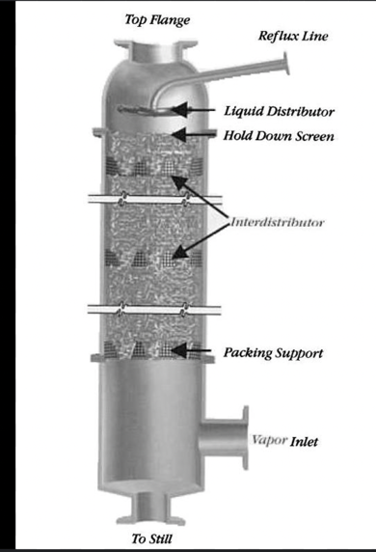
    - Most often used for absorption, can also be used for the distillation of vapor-liquid mixtures
Visual
    - Provide larger surface area for vapor-liquid contact, increases column effectiveness
    - Feed contains components of different volatilities, and it enters at the middle of the column
    - The difference in concentration causes the less-volatile components to transfer from the vapor phase to the liquid phase
    - Packing increases the time of contact which increases the separation efficiency
    - From the visual: the feed enters the column, liquid flows downward while vapor rises upward through the packing, the vapor picks up lighter volatile substances, at the bottom the liquid goes to the reboiler, partly boiled. Then the vapor goes back up the column and leaves the remaining liquid at the bottom. At the top it enters a condenser where its cooled and turned into liquid. In the reflux drum it splits the distillate (product) and the reflux is returned into the column to improve separation.
    - Usage:
      - Used to recover solvents
      - Suitable for thermally sensitive liquids and low-pressure operations
  - Plate or tray column
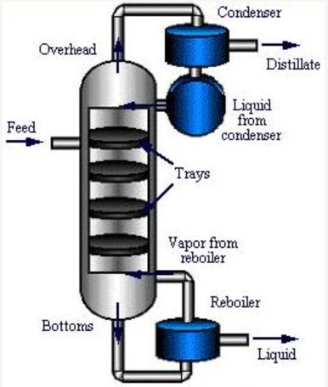
    - The number of trays or stages in the column is dependent on the desired purity and difficulty of separation.
Visual
    - The number of stages determines the height of the column
    - The feed enters a plate column towards the middle of the column, and the concentration differences cause the less volatile components to transfer from the vapor stream to the liquid stream
    - The vapor exiting the condenser has the most volatile components
    - The least volatile components exit through the reboiler in the liquid stream
    - The liquid flows down the column and across the trays in either crossflow or countercurrent flow.
    - The reboiler at the bottom separates the stream into a vapor stream that returns to the column and a liquid product stream.
    - The vapor stream flows upward through the trays and contacts the down flowing liquid stream allowing the separation to take place.
    - Usage:
      - Often used to recover solvents from process wastes
      - Used to purify solvents from hazardous material
    - Can handle high liquid flow rates cost effectively
  - Advanced distillation techniques
    - Vacuum
    - To vaporize a liquid, its temperature can be raised, or its pressure can be decreased
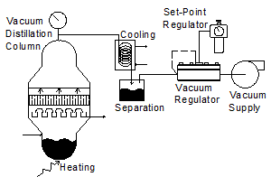
    - In this type of distillation, the pressure inside the distillation column is maintained at a vacuum to lower the temperature needed to vaporize the liquid.
Visual
    - This method is applied to situations with heat-sensitive products, liquids with low viscosities and liquids that tend to foul or foam
    - Vacuum pumps are added to the distillation system to decrease the column pressure below atmospheric pressure
    - Vacuum regulators are used to ensure that the pressure within the column is maintained in a vacuum.
    - Careful pressure control is important because the separation is dependent on the differences in relative volatility at a given temperature and pressure
    - Usage:
      - Used in oil refineries, this allows for higher boiling point hydrocarbon such as lubricants and waxes to be separated at economical temperatures.
      - Separation of sensitive organic chemicals and recovery of organic solvents
    - Columns can be operated at lower temperatures
    - High energy cost of vacuum pumps and large column diameters are needed for the process to be efficient
  - Cryogenic distillation
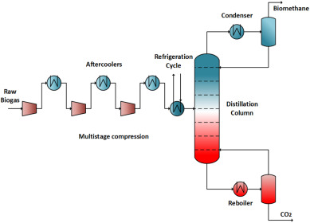
    - A very cold version of distillation and is used to separate gasses
Visual
    - Works by cooling gas mixtures to extremely low temperatures below -150°C so that gasses turn into liquids and can then be separated based on their boiling points
    - Heat exchangers and cooling coils lower the temperature inside the distillation column calling it a cold box
    - The cryogenic gasses are fed into the cold box and distilled at very low temperatures
    - The column can be either packed bed or plate design, the plate design being preferred since packing material is less efficient at lower temperatures
    - Example air or natural gas is cooled; the top of the column gives lighter gasses such as nitrogen and at the bottom is the heavier gasses like oxygen or argon.
    - Usage:
      - Air separation plants to make industrial gasses
      - Natural gas processing to remove impurities and separate methane, ethane etc.
      - Rocket fuel and medical oxygen production where very pure gasses are needed.
    - Can produce gaseous and liquid products
    - High energy costs
  - Reactive distillation or catalytic distillation
    - Combines reaction and distillation in a single column, chemical reaction and separation happen at the same time in the same unit
    - Can replace a separate reactor and distillation column system
Visual
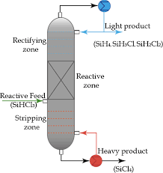
    - Have reactive zone lined with catalyst bales
    - Feed enters the column containing reactants that can react with each other
    - Inside the column a catalyst (solid material that speeds up the reaction) is placed in special trays or packing
    - The reaction occurs as liquid and vapor flow through the catalyst and are the same time distillation separates the products and unreacted materials
    - More volatile products leave the top and heavier components leave from the bottom
    - Usage:
      - Many refineries produce methyl-tertbutyl ether (MTBE) (chemical compound from isobutene + methanol) oxygen containing fuel additives (add oxygen to gasoline) which is used to improve gasoline performance and reduce air pollution
  - Extractive
    - For distillation process used when two liquids are hard to separate because they have very similar boiling points or form an azeotrope (mixture that boils at constant temperature)
Visual
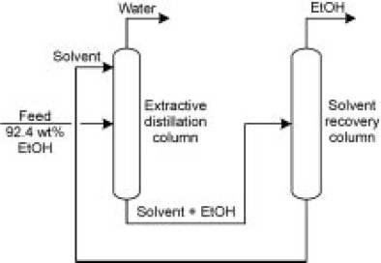
    - A special solvent is added near the top of the column and this solvent has a high boiling point
    - The component less affected by the solvent turns to vapor and leaves through the top
    - The component attracted to the solvent stays lower and leaves the solvent at the bottom
    - Example separating benzene and cyclohexane
  - Pressure swing
    - Used to separate azeotropic mixtures
    - Uses two or more distillation columns operating at different pressures, changing the pressure changes the boiling points and the azeotropic composition allowing the components to be separated.
    - Used to separate ethanol and water
    - Avoids using solvents
https://encyclopedia.che.engin.umich.edu/distillation-columns/
https://www.hyper-tvt.ethz.ch/distillation-multiplefeed.html

Power point presentation outline:
Slide 1: Introduction:
Slide 2: Material balance definition
Slide 3: Basic formula
Slide 4: batch
Slide 5: continuous
Slide 6: semi batch
Slide 7: steady state
Slide 8: non steady state
Slide 9:Problem 4
Slide 10: degree of freedom analysis
Slide 11: approach
Slide 12: assumptions
Slide 13: roadmap/ flowchart filled out
Slide 14: excel sheet
Slide 15: approach 1, basic
Slide 16: approach 2, more efficient using solver
Slide 17: pseudocode
Slide 18: our MATLAB code
Slide 19: Distillation column definition
Slide 20: connects with our problem
Slide 21: Different types
Slides 22: packed beds
Slide 23:plate/tray
Slide 24: vacuum
Slide 25: cryogenic
Slide 26: reactive
Slide 27: Extractive
Slide 28: Pressure Swing
Slide 29: Key findings
Slide 30: Conclusion

